1. **HostGator is responding very slow**. With 10-12 Users at one point of time the Server is not responding. -🡪Done
2. **G-Suite** – Pls attach G-Suite to mail id : [support@nibmt.org](mailto:support@nibmt.org) 🡪Working
3. Put the **Govt Approved Logo** with TM sign on the Homepage (mailed by Arpit) 🡪Done
4. On Homepage, many URL’s are not working fine 🡪Done



1. **SSL Certification** – Pls put the SSL of Hostgator offered with the Package 🡪Working
2. **Google Analytics** – Pls Join Google Analytics to URL [www.nibmt.org](http://www.nibmt.org) 🡪 Pending
3. **Library Page is Not Working completely**. Library Page should have a form which will capture all the details of the person downloading e-books. 🡪Working
4. **Be Our Teacher Page –** 
   * Count is not coming properly 🡪Done
   * Register Form on this page is not coming properly 🡪Working
5. **From Footer**– Pls remove below: 🡪Done

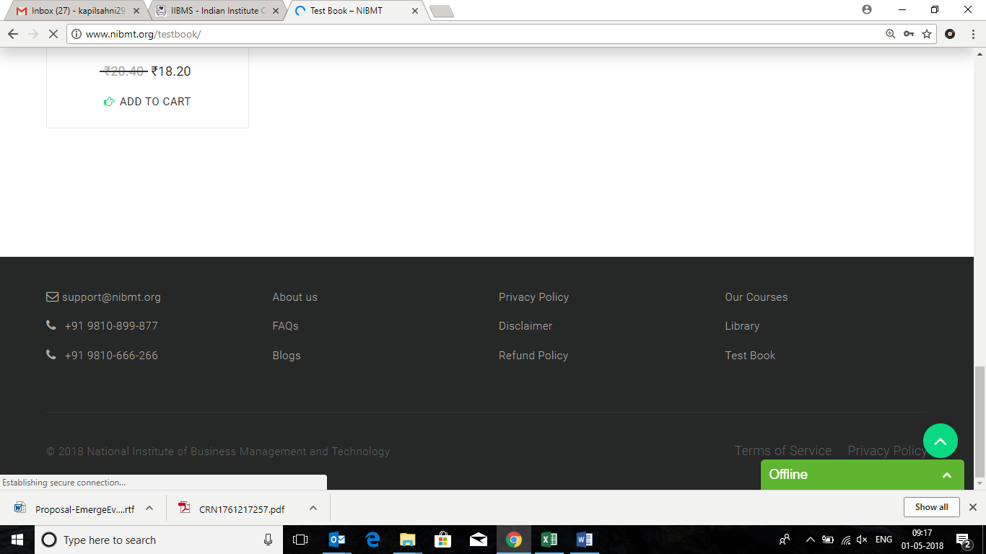

**My Profile**

* Phone Number and Avatar to be removed 🡪Done

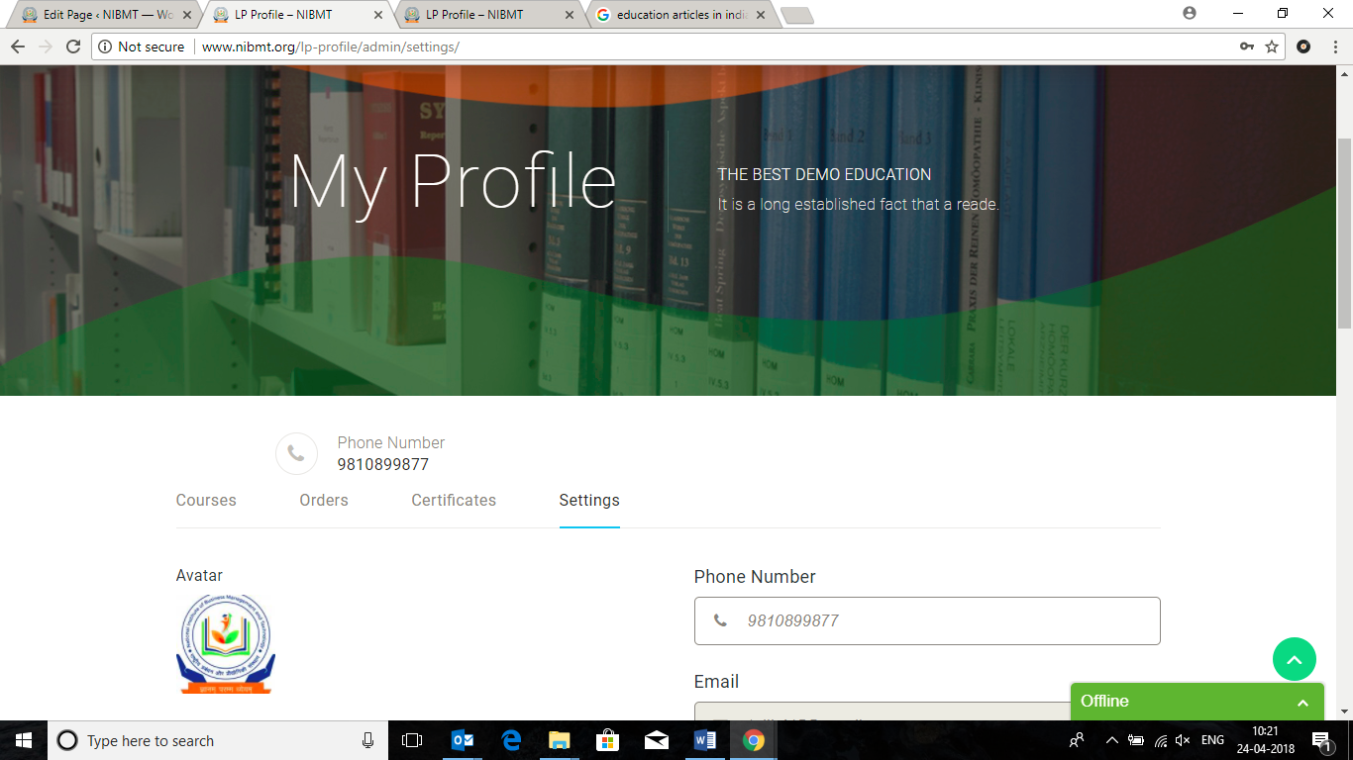

* Change Password option not working in **My profile** section

**>>TALIB 🡪 DONE**

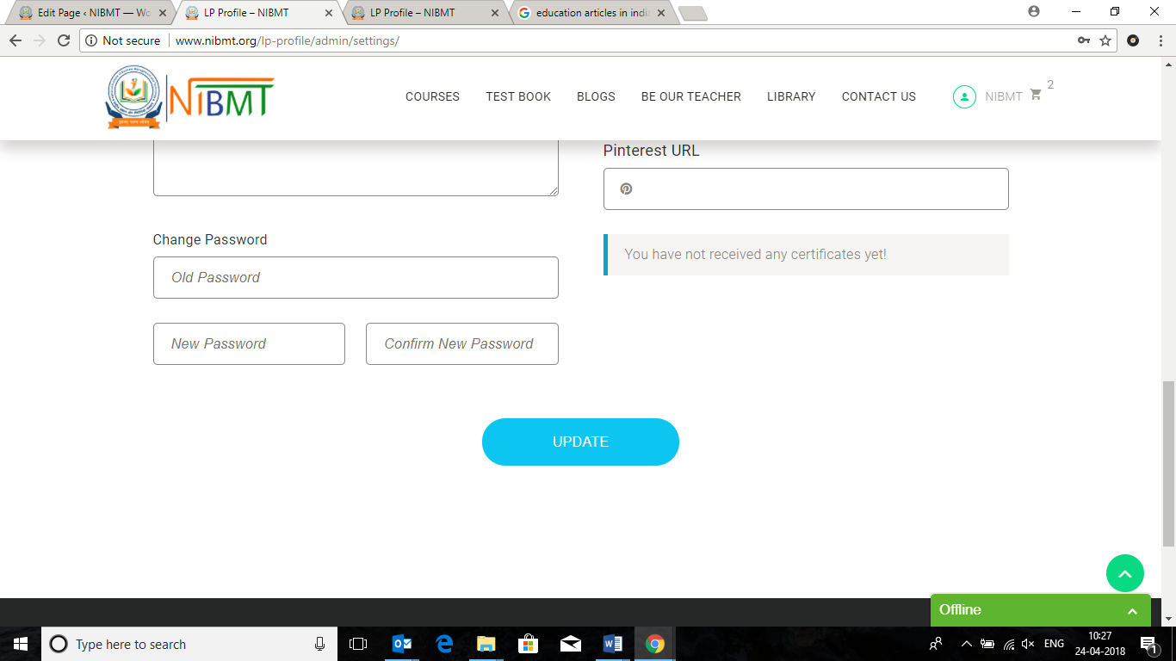

**Courses**

* Remove the Related Courses section from here

**>>TALIB 🡪 DONE**



* Activate the Review section - ***** for all the courses

**>>TALIB 🡪 is only applicable in Paid Plugin**

**Blogs**

* Search Functionality & Grid/ List View to work in the Blogs section🡪Pending
* How to make changes in the Categories – Blogs? 🡪 Tell Him Over The phone
* Like we want to change the Image etc…
  + Blogs -> Education (Category)

**>> ALL POINTS TALIB**

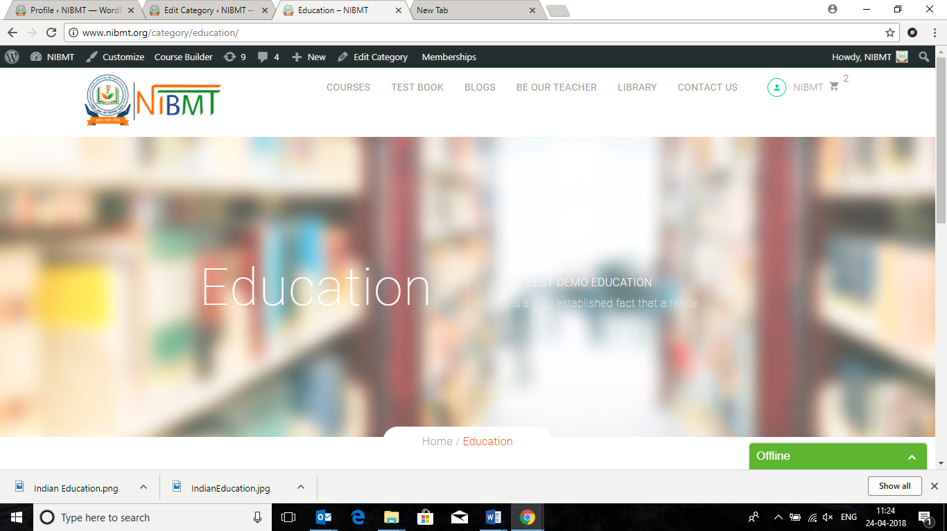

* How to change the Banner of Tags in Blogs ? 🡪Pending

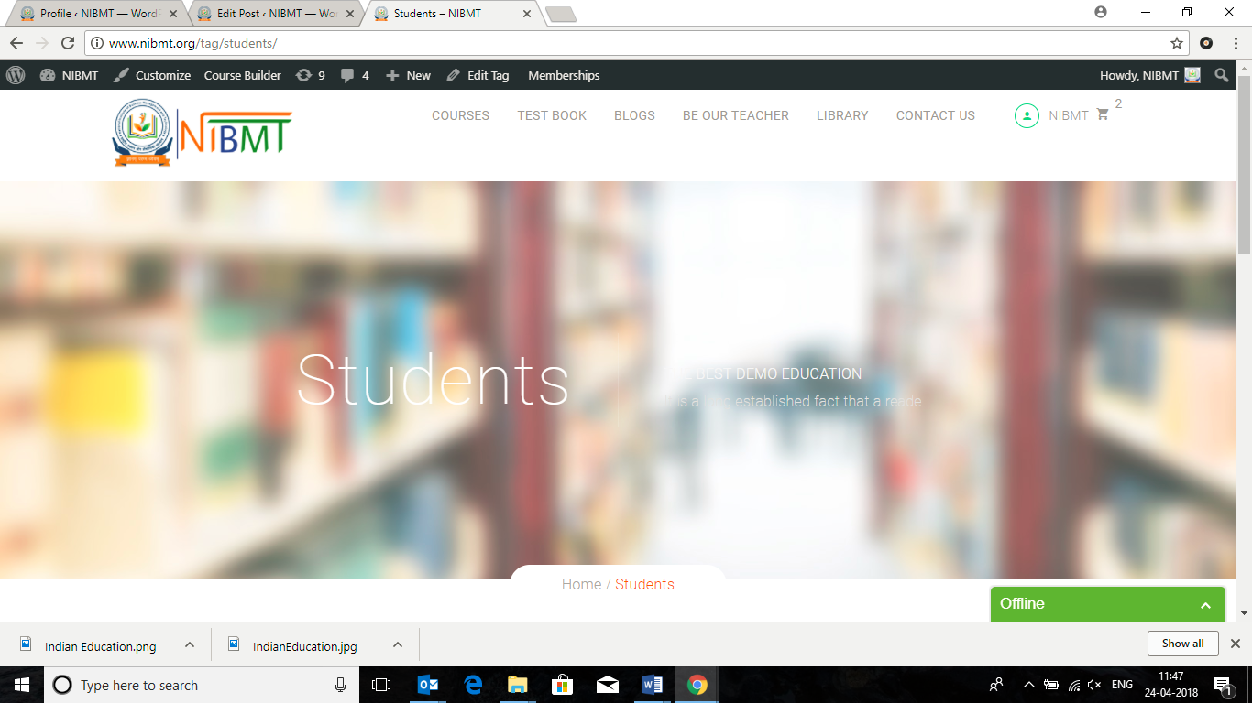

**Library**

* Search Functionality & Grid/ List View to work in the Blogs section

>>TALIB --> DONE

* Change USD to ₹ 🡪 Done

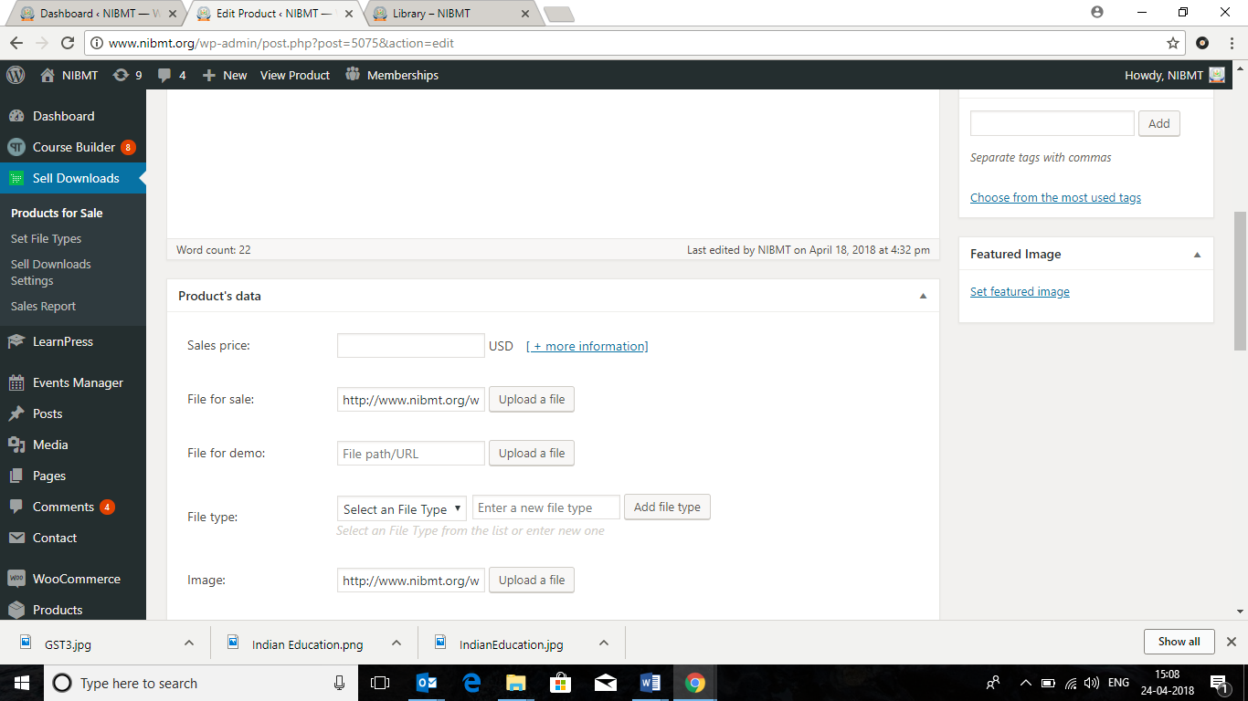

* Pls de-activate this Description Page, it is not required. --> Done
* Remove the Permalink from all Library section layout

**>>TALIB --> Done**

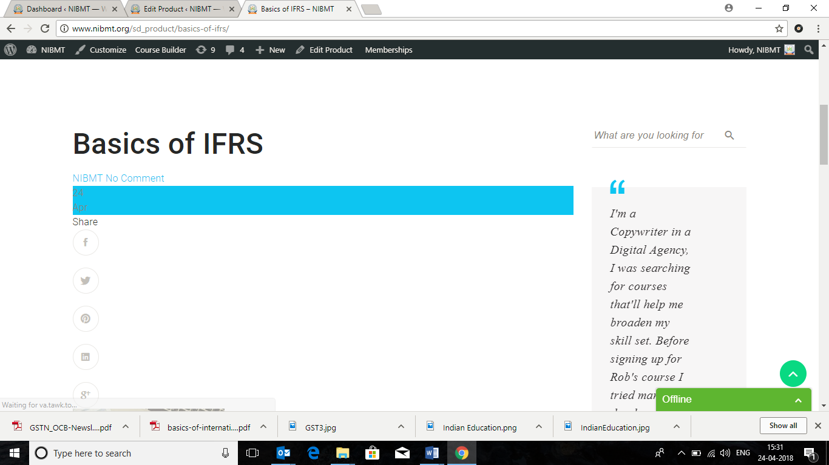

* ***Any Person who download the e-book needs to fill up below FORM - field’s.***
  + Name,
  + Mobile
  + EMail.
* This Form Database is not visible in the Admin Panel. Database has to come in the Admin Panel.
* Instead of **PAY** we need to write **SUBMIT**

**>> ALL POINTS TALIB 🡪Pending**

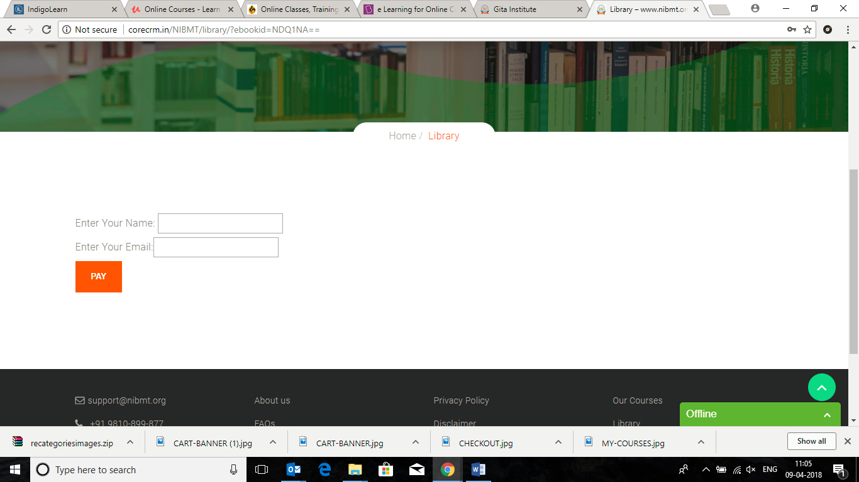

**On the HOME PAGE**

* Where is this page coming from? Go To 🡪 LearnPress 🡪Collections
* Need to change the url of SEE ALL COURSES

>> TALIB 🡪 Have Query Against??



**Put the link -** [**http://www.nibmt.org/lp-courses/**](http://www.nibmt.org/lp-courses/)

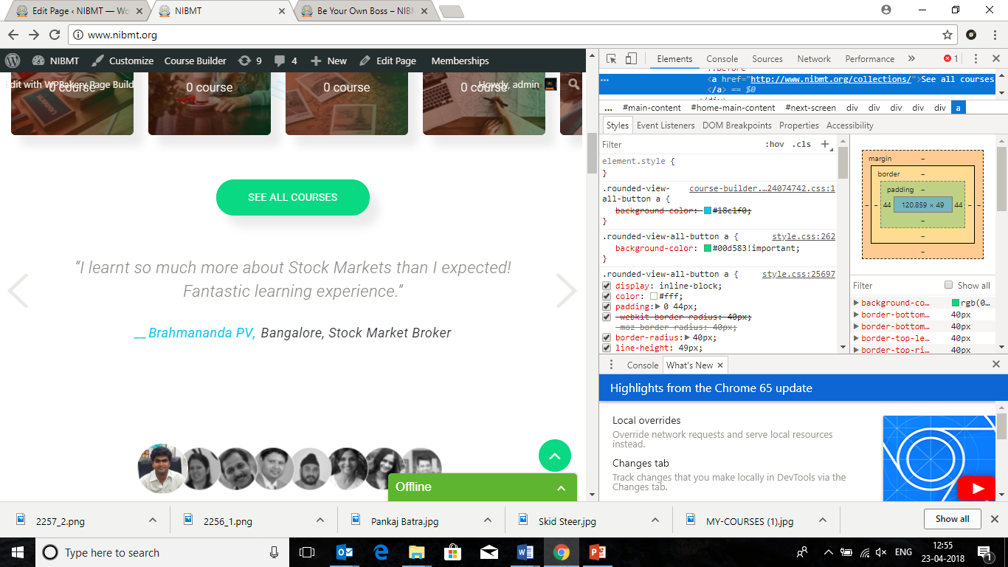

**On the Be Our Teacher Page**

* Steps are not navigating/ moving 🡪 Pending

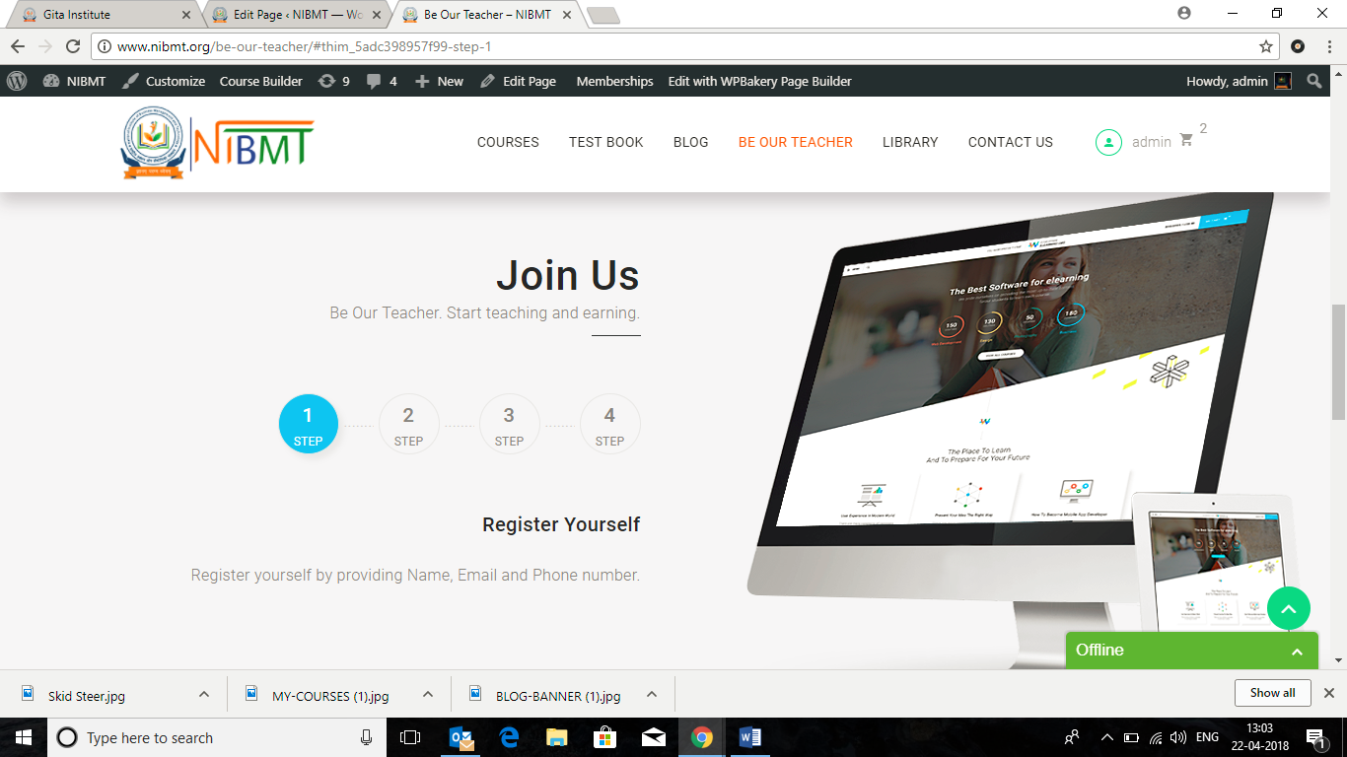

* Why is it saying that Please login to fill this form. This should work without Logging In.

>>TALIB 🡪Pending

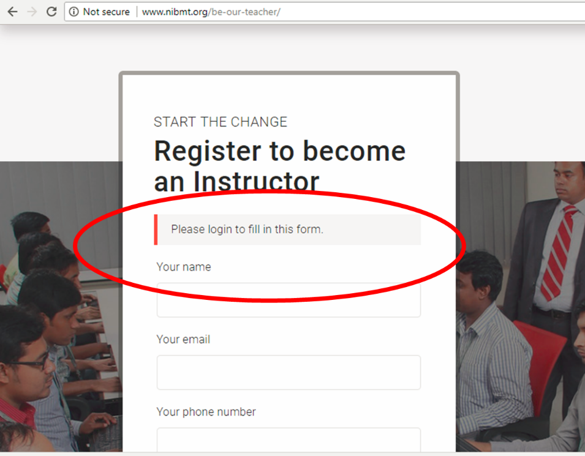

**On the My Profile Page**

Pls re-name the sections as: 🡪Pending

* 1. **My Courses**
  2. **My Orders**
  3. **My Certificates**
  4. **My Profile**

**>>TALIB**

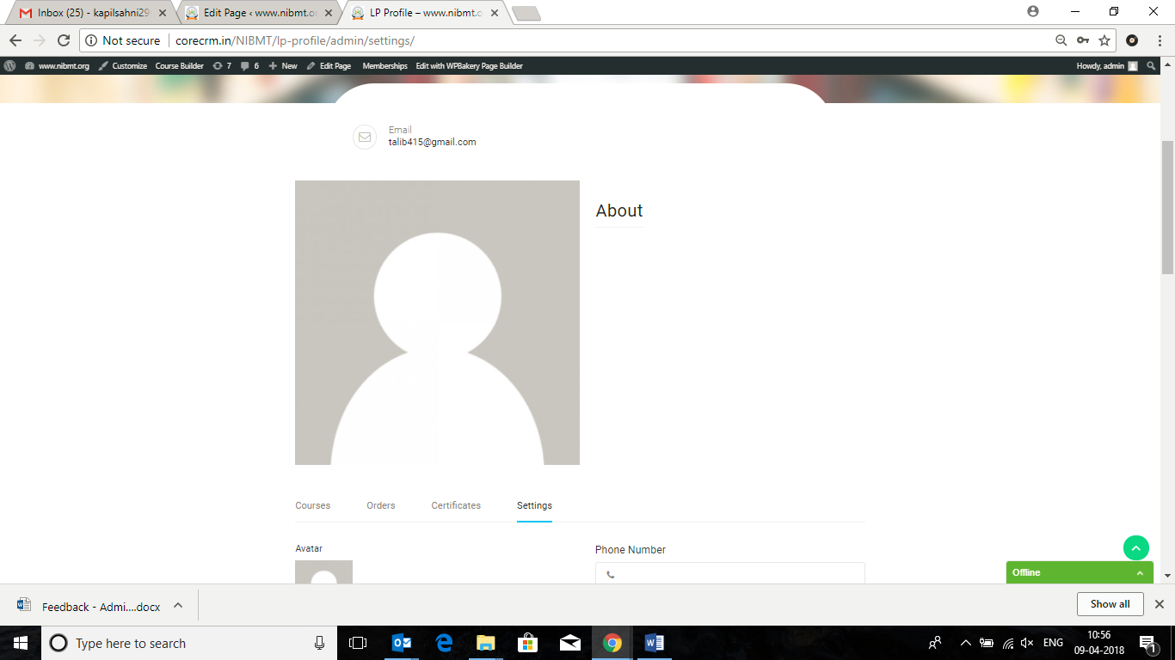

***In the User Registration Page***

***Please make the below change in the HEADLINE.***

***>> TALIB 🡪 Pending***

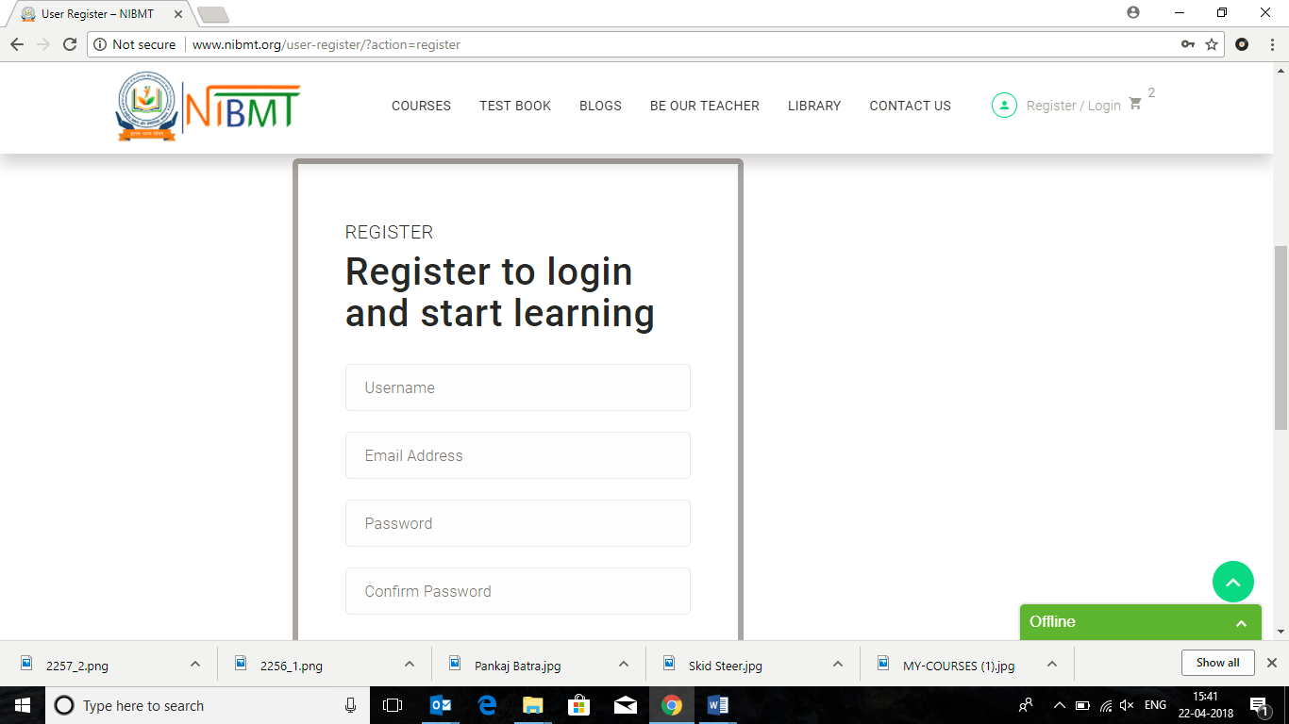

* Remove

Want to be an Instructor

Functionality in the bottom

**Register to**

**India’s best certified courses**

**Upcoming Events**

* Remove this Image from the Navigated Page

**>>TALIB 🡪 Pending**



**Test Book**

* Unable to download any Test Series file even after making all the Payment
* Pls correct this

**>> TALIB 🡪 Pending**

